Hearing Loss

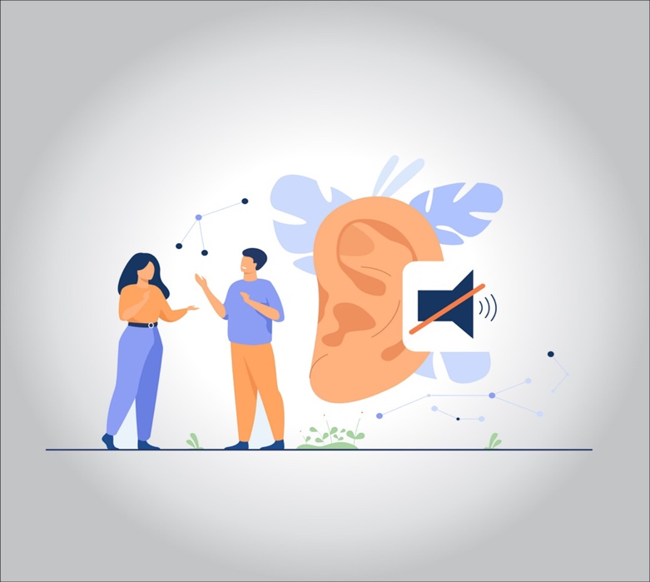

**Hearing loss that occurs gradually as you age is common.**

**Hearing loss is defined as one of three types:**

* **Conductive (involves outer or middle ear)**
* **Sensorineural (involves inner ear)**
* **Mixed (combination of the two)**

**Symptoms**

* **Signs and symptoms of hearing loss may include:**
* **Muffling of speech and other sounds**
* **Difficulty understanding words, especially against background noise or in a crowd**
* **Trouble hearing consonants**
* **Frequently asking others to speak more slowly, clearly and loudly**
* **Needing to turn up the volume of the television or radio**
* **Withdrawal from conversations**
* **Avoidance of some social settings**

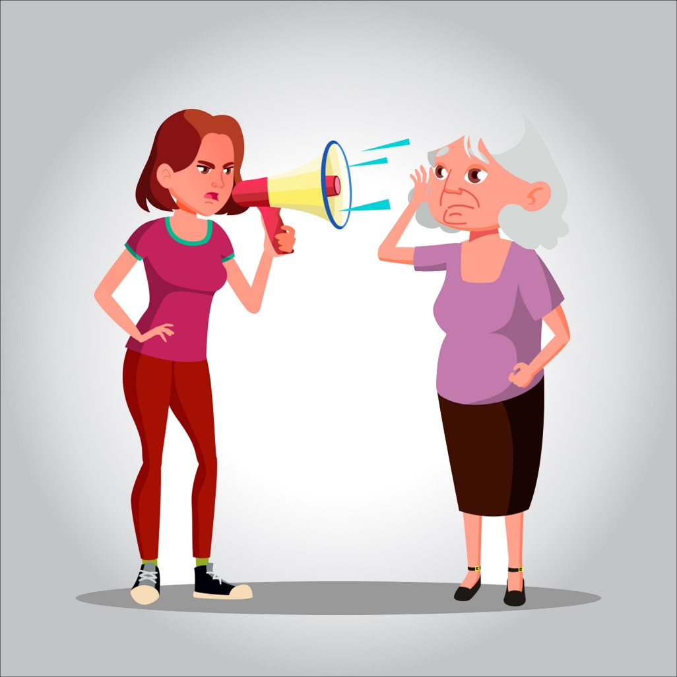

**Aging and chronic exposure to loud noises both contribute to hearing loss. Other factors, such as excessive earwax, can temporarily reduce how well your ears conduct sounds.**

**You can’t reverse most types of hearing loss. However, you and your doctor or a hearing specialist can take steps to improve what you hear.**

**How hearing loss can occur?**

**Causes of hearing loss include:**

* **Damage to the inner ear. Aging and exposure to loud noise may cause wear and tear on the hairs or nerve cells in the cochlea that send sound signals to the brain. When these hairs or nerve cells are damaged or missing, electrical signals aren’t transmitted as efficiently, and hearing loss occurs.**
* **Higher pitched tones may become muffled to you. It may become difficult for you to pick out words against background noise.**
* **The gradual buildup of earwax. Earwax can block the ear canal and prevent the conduction of sound waves. Earwax removal can help restore your hearing.**
* **Ear infection and abnormal bone growths or tumors. In the outer or middle ear, any of these can cause hearing loss.**
* **Ruptured eardrum (tympanic membrane perforation). Loud blasts of noise, sudden changes in pressure, poking your eardrum with an object and infection can cause your eardrum to rupture and affect your hearing.**

**Treatment**

**If you have hearing problems, help is available. Treatment depends on the cause and severity of your hearing loss. Options include:**

* **Removing wax blockage. Earwax blockage is a reversible cause of hearing loss. Your doctor may remove earwax using suction or a small tool with a loop on the end.**
* **Surgical procedures. Some types of hearing loss can be treated with surgery, including abnormalities of the ear drum or bones of hearing (ossicles). If you’ve had repeated infections with persistent fluid, your doctor may insert small tubes that help your ears drain.**
* **Hearing aids. If your hearing loss is due to damage to your inner ear, a hearing aid can be helpful. An audiologist can discuss with you the potential benefits of a hearing aid and fit you with a device. Open fit aids are currently the most popular, due to fit and features offered.**
* **Cochlear implants. If you have more severe hearing loss and gain limited benefit from conventional hearing aids, then a cochlear implant may be an option. Unlike a hearing aid that amplifies sound and directs it into your ear canal, a cochlear implant bypasses damaged or nonworking parts of your inner ear and directly stimulates the hearing nerve. An audiologist, along with a medical doctor who specializes in disorders of the ears, nose and throat (ENT), can discuss the risks and benefits.**

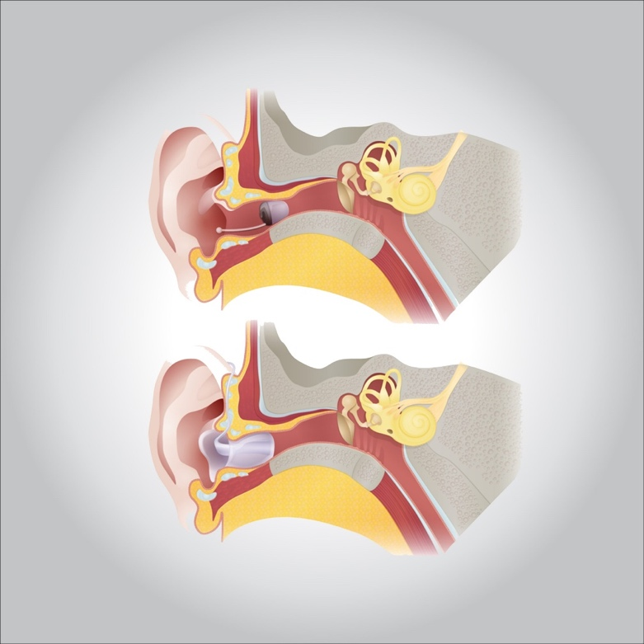

**Risk factors**

**Factors that may damage or lead to loss of the hairs and nerve cells in your inner ear include:**

* **Aging. Degeneration of inner ear structures occurs over time.**
* **Loud noise. Exposure to loud sounds can damage the cells of your inner ear. Damage can occur with long-term exposure to loud noises, or from a short blast of noise, such as from a gunshot.**
* **Heredity. Your genetic makeup may make you more susceptible to ear damage from sound or deterioration from aging.**
* **Occupational noises. Jobs where loud noise is a regular part of the working environment, such as farming, construction or factory work, can lead to damage inside your ear.**
* **Recreational noises. Exposure to explosive noises, such as from firearms and jet engines, can cause immediate, permanent hearing loss. Other recreational activities with dangerously high noise levels include snowmobiling, motorcycling, carpentry or listening to loud music.**
* **Some medications. Drugs such as the antibiotic gentamicin, sildenafil (Viagra) and certain chemotherapy drugs, can damage the inner ear. Temporary effects on your hearing — ringing in the ear (tinnitus) or hearing loss — can occur if you take very high doses of aspirin, other pain relievers, antimalarial drugs or loop diuretics.**

**Some illnesses. Diseases or illnesses that result in high fever, such as meningitis, may damage the cochlea.**